Communications Project
Submitted to: Dr. Ahmed Hesham

Block Designs:
AM Modulator:
I designed it using a simple single tone cosine carrier multiplied by the message. Each message is modulated over a frequency of 100K + (55K*n) Hz.
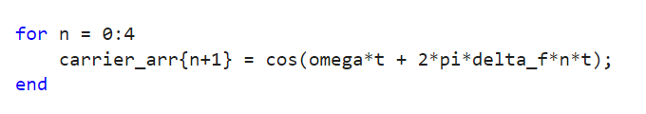
RF Stage:
I used filterDesigner for designation of the BPF, exported it to my workspace as an object and used it using the function filter.
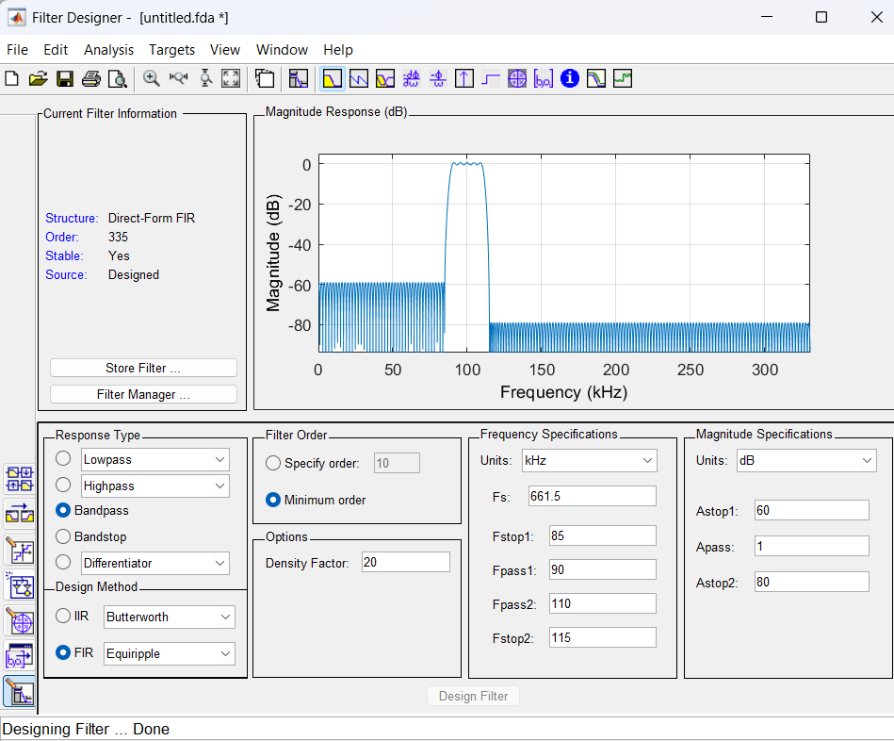

Oscillator & Mixer:
Same as the carriers, this was a cosine function with omega = omega_IF + omega_signal, the mixer is a simple multiplier.
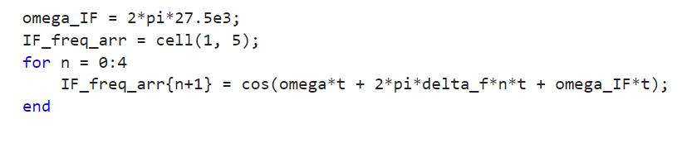

IF Stage:
A bandpass filter with center frequency at 27.5KHz and BW = 20KHz (BW of original signal)
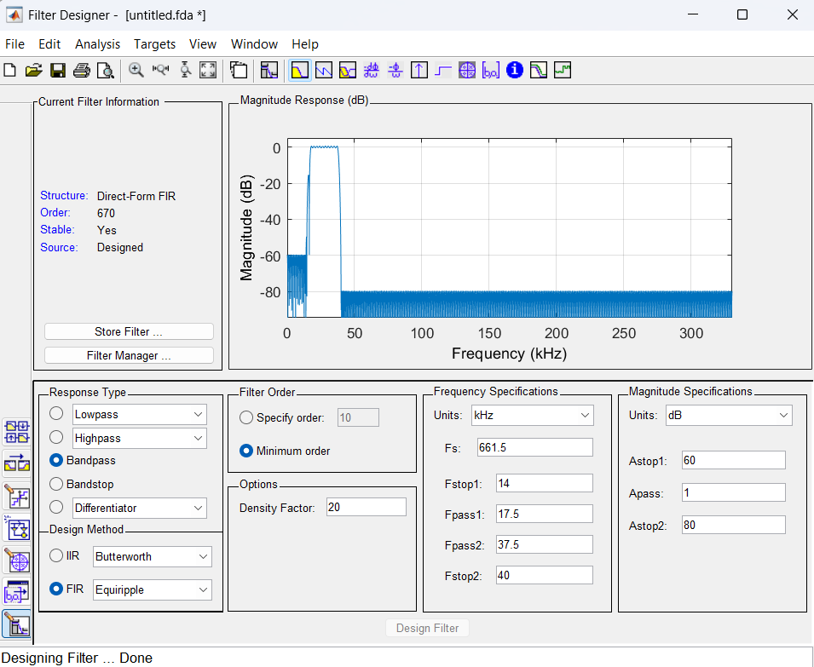

Bandpass Detection:
I multiplied the filtered signal by cos(2*pi*27.5e3*t) to return the signal to baseband, then used a LPF of BW = 10 KHz (BB signal BW)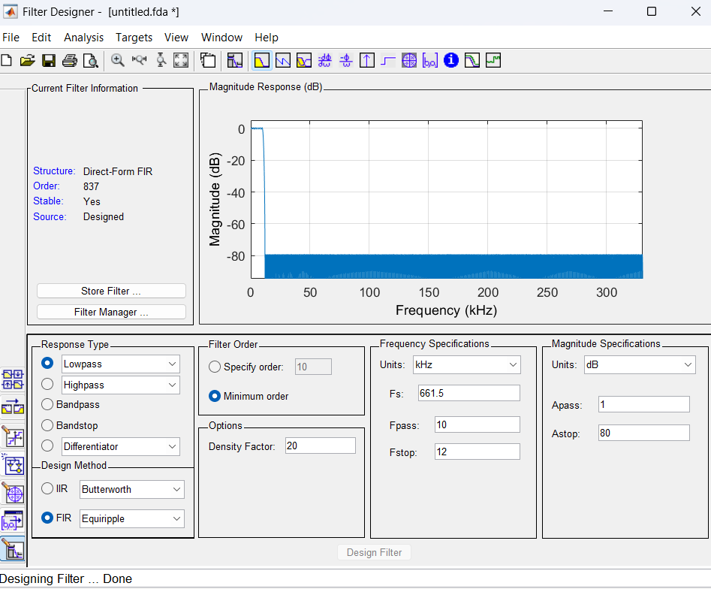
Answers:
Q1)
In two or three sentences, discuss the role of the RF, the IF and the baseband detector. Indicate why we need the IF stage?
Answer: The role of the RF stage is to filter unwanted signals which cause image problems and interference problems. They also represent unwanted power. The role of the IF stage is to solve DC leakage problems, flicker noise problems and quadrature errors problems. The baseband detector is supposed to return the signal to its original state at baseband. Also, it filters unwanted signals at higher frequencies due to the mixer.

Q2) Suppose you want to demodulate the first station (i.e. at 𝜔0), plot the spectrum of the outputs of the RF, the IF and the baseband stages. Hint: use the ‘fft’ command in MATLAB. You may also find the ‘fftshift’ command useful.

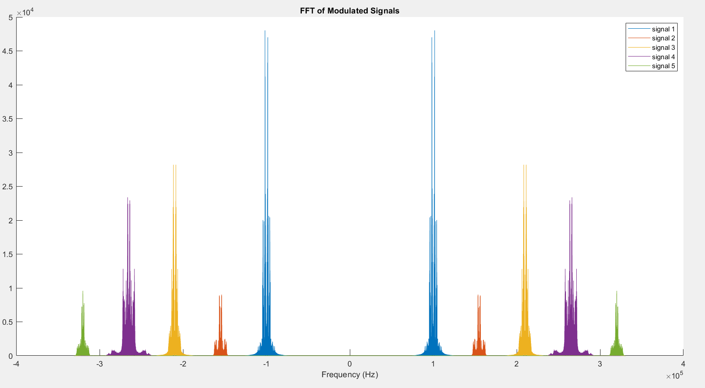
Answer: output of all modulated signals:

Output at RF Stage: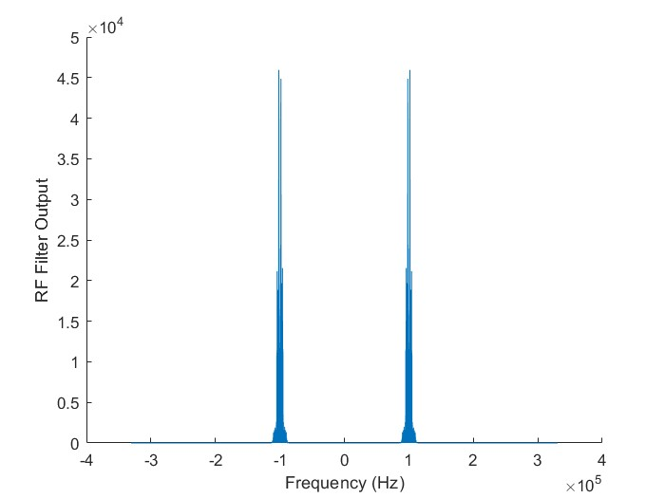

Output at IF Stage: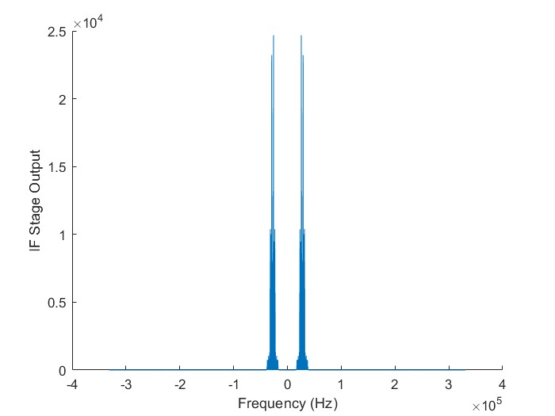

Output at Baseband: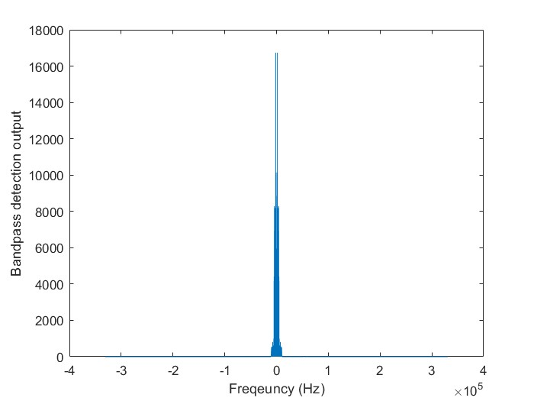
Q3) Use the command ‘sound’ on the demodulated signal and check whether you can successfully listen to the radio station. Please comment about this step in your report

Answer: Yes, I can listen clearly to the transmitted signal. Without any interference thanks to the BPF at the RF stage.

Q4) Repeat parts 2 and 3 but after removing the RF BPF. That is, the RF stage does not exist, what would happen if you try to demodulate the station at 𝜔0?
Answer: Output at IF Stage: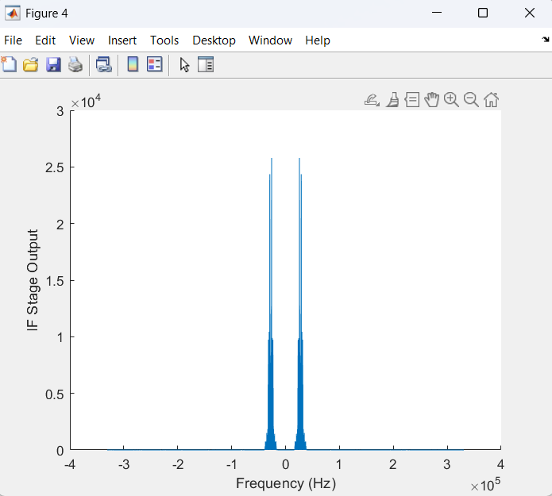

Output at BB: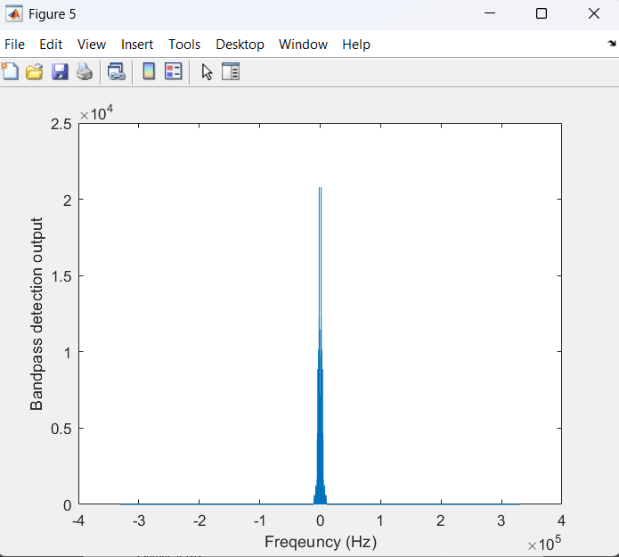
I’m hearing 2 signals at the same time. That is expected as image problem will occur due to next signal existing at Fc + 55KHz (2*Fimage).

Q5) What happens (in terms of the spectrum and the sound quality) if the receiver oscillator has frequency offset by 0.1 KHz and 1 KHz?
At 100 Hz offset:
IF Stage Output: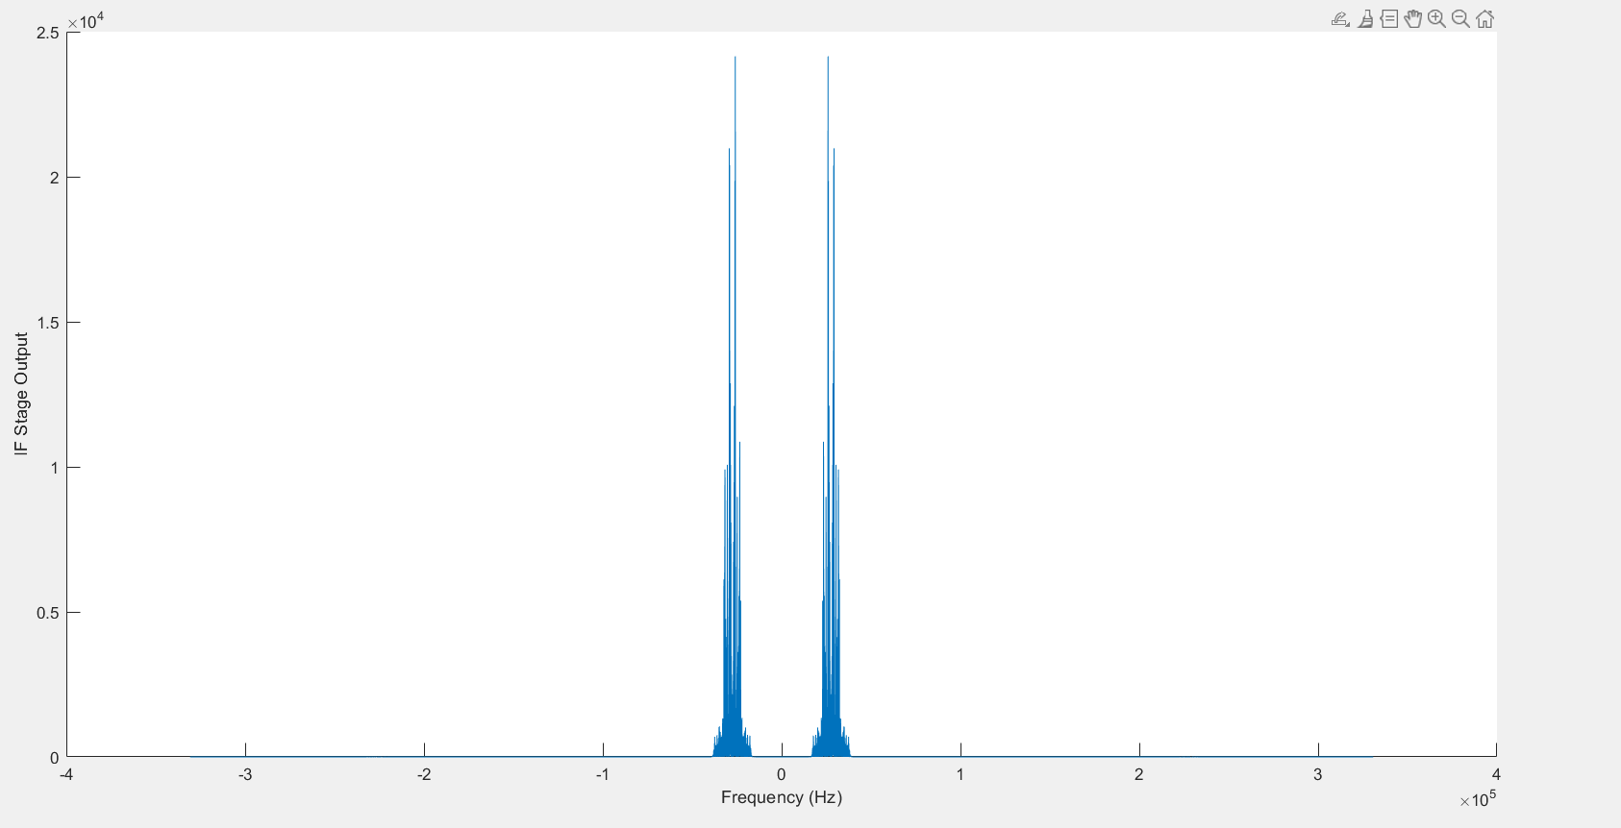
BB Output:
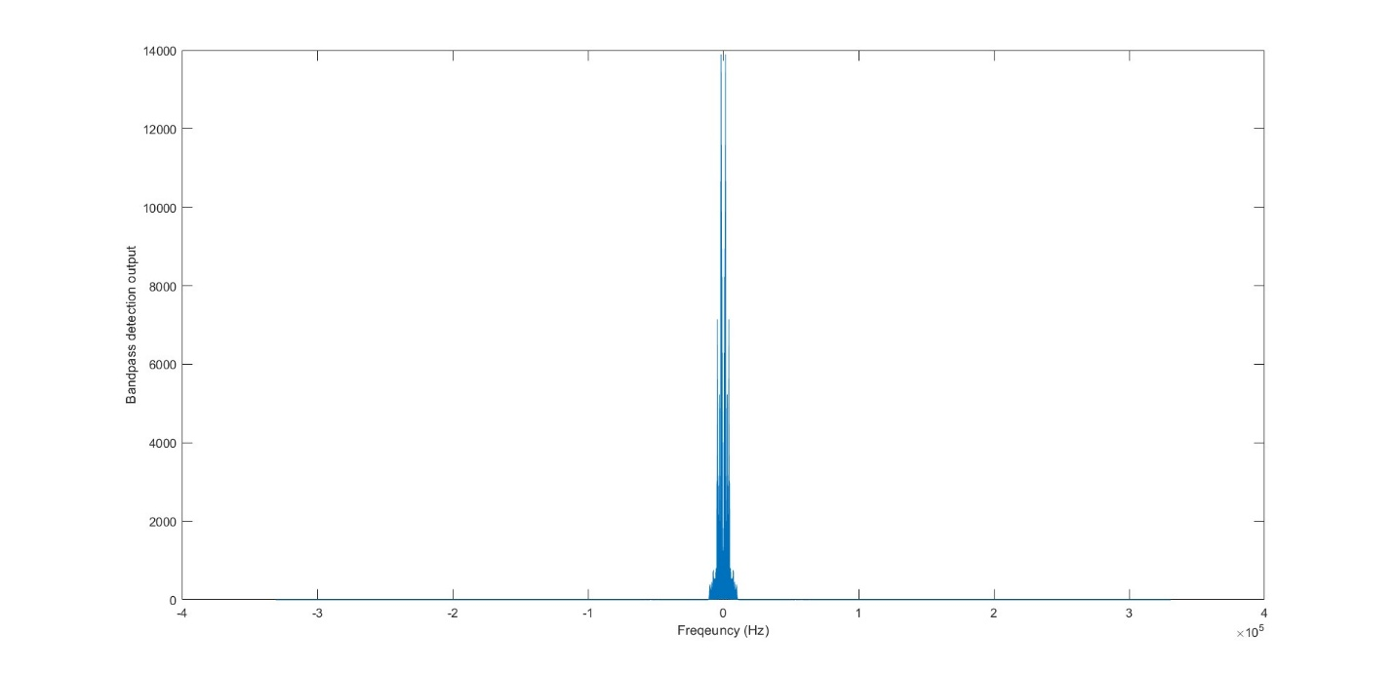
Signal is distorted and a little creepy, but it is still hearable and I can understand what is being said. Center frequency at IF stage shifts by 0.1KHz and BW of BB signal is cut by 100 HZ.
At 1KHz offset:
IF Output: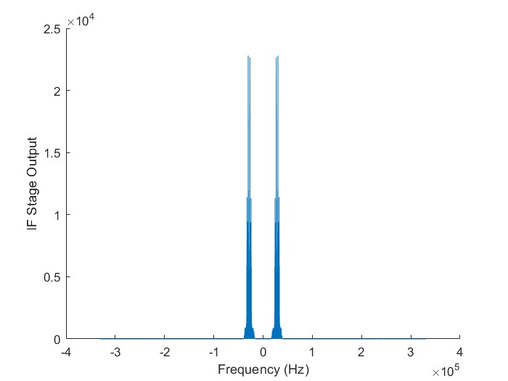

BB Output”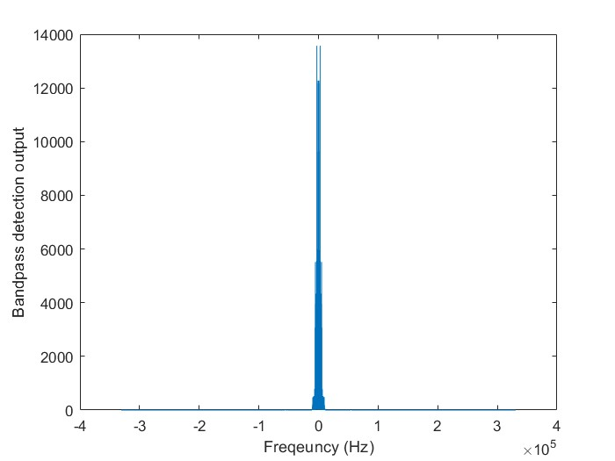
Signal is completely distorted. I can’t understand a word that is being said. Baseband BW is cut by 1KHz. The center frequency at the IF stage is now 26.5KHz.

Code:

[x1] = audioread("Short_QuranPalestine.wav");
[x2] = audioread("Short_BBCArabic2.wav");
[x3] = audioread("Short_FM9090.wav");
[x4] = audioread("Short_RussianVoice.wav");
[x5, fs] = audioread("Short_SkyNewsArabia.wav");

audioarray = {x1, x2, x3, x4, x5};

% creating 1 single channel by averaging both channels
for i = 1:5
audioarray{i} = (audioarray{i}(:,1) + audioarray{i}(:,2)) / 2;
end

% padding all function with zero for them to be the same length
maxN = max(cellfun(@length, audioarray));
for i = 1:5
audioarray{i} = [audioarray{i}; zeros(maxN - length(audioarray{i}), 1)];
end

f = (-maxN/2:maxN/2-1) * (fs/maxN); % Frequency Axis

figure; hold on;
for k = 1:5
X = fft(audioarray{k});
plot(f, fftshift(abs(X)));
end
xlabel('Frequency (Hz)');
ylabel('FFT');
title('FFT of Message Signals');
hold off;

% We can observe BW to be equal to around 10KHZ

for i = 1:5
audioarray{i} = interp(audioarray{i}, 15);
end
fs_new = 15*fs;
maxN_new = length(audioarray{1});

omega = 2*pi*100e3; % carrier radian freq
delta_f = 55e3;
Ts = 1/fs_new;
t = (0:maxN_new-1)' * Ts;

carrier_arr = cell(1,5);

for n = 0:4
carrier_arr{n+1} = cos(omega*t + 2*pi*delta_f*n*t);
end

f_new = (-maxN_new/2:maxN_new/2 - 1) * (fs_new/maxN_new);

figure; hold on;
for k = 1:5
A = fft(carrier_arr{k});
plot(f_new, fftshift(abs(A)));
end
xlabel('Frequency (Hz)');
ylabel('FFT');
legend('carrier 1','carrier 2','carrier 3','carrier 4','carrier 5');
title('FFT of Carrier Signals');
hold off;

modulated_signals = cell(1, 5);

for i = 1:5
modulated_signals{i} = audioarray{i} .* carrier_arr{i};
end

figure; hold on;
for k = 1:5
B = fft(modulated_signals{k});
plot(f_new, fftshift(abs(B)));
end
xlabel('Frequency (Hz)');
ylabel('FFT');
legend('signal 1','signal 2','signal 3','signal 4','signal 5');
title('FFT of Modulated Signals');
hold off;

Mixed_signal = 0;
for i = 1:5
Mixed_signal = Mixed_signal + modulated_signals{i};
end
BPF1_out = filter(HDBPF1, Mixed_signal);
BPF1_out_FFT = fft(BPF1_out);
figure; hold on;
plot(f_new, fftshift(abs(BPF1_out_FFT)));
xlabel('Frequency (Hz)');
ylabel('RF Filter Output');
hold off;

omega_IF = 2*pi*27.5e3;
IF_freq_arr = cell(1, 5);
for n = 0:4
IF_freq_arr{n+1} = cos(omega*t + 2*pi*delta_f*n*t + omega_IF*t);
end

IF_BPF1_out = filter(HDIFBPF1, BPF1_out .* IF_freq_arr{1});
figure; hold on;
plot(f_new, fftshift(abs(fft(IF_BPF1_out))));
xlabel('Frequency (Hz)');
ylabel('IF Stage Output');
hold off;
Demodulated_Signal1 = filter(LPF1, IF_BPF1_out .* cos(omega_IF*t));
figure;
plot(f_new, fftshift(abs(fft(Demodulated_Signal1))));
xlabel('Freqeuncy (Hz)');
ylabel('Bandpass detection output');
Demodulated_Signal1 = downsample(Demodulated_Signal1, 15);
soundsc(Demodulated_Signal1, fs);

